A PRELIMENERY REPORT ON PREDICTIVE MAINTAINANCE MODEL

SUBMITTED TO THE VISHWAKARMA INSTITUTE OF INFORMATION TECHNOLOGY, PUNE
IN THE PARTIAL FULFILLMENT OF THE REQUIREMENTS
FOR THE AWARD OF THE DEGREE

BACHELOR OF TECHNOLOGY (COMPUTER ENGINEERING)

SUBMITTED BY

Manas Darak 22111051
Saurabh Jadhav 22111154
Saksham Kapadnis 22111245
Yash Fulse 22110117



DEPARTMENT OF COMPUTER ENGINEERING

BRACT’S
VISHWAKARMA INSTITUTE OF INFORMATION TECHNOLOGY

SURVEY NO. 3/4, KONDHWA (BUDRUK), PUNE – 411048, MAHARASHTRA (INDIA).

Sr. No. |  |  |  | Title of Chapter |  | Page No.
01 |  |  |  | Introduction |  | 3
 | 1.1 |  |  | Overview |  | 3
 | 1.2 |  |  | Motivation |  | 3
 | 1.3 |  |  | Problem Definition and Objectives |  | 3
 | 1.4 |  |  | Project Scope & Limitations |  | 4
 | 1.5 |  |  | Methodologies of Problem solving |  | 4
02 |  |  |  | Literature Survey |  | 5
03 |  |  |  | System Design |  | 5
 |  | 3.1 |  | System Architecture |  | 5
04 |  |  |  | Project Implementation |  | 6
 |  |  | 4.1 | Overview of Project Modules |  | 6
 |  |  | 4.2 | Tools and Technologies Used |  | 6
 |  |  | 4.3 | Algorithm Details |  | 6
 |  |  |  | 4.3.1 | Algorithm 1 | 6
 |  |  |  | 4.3.2 | Algorithm 2 | 7
 |  |  |  | 4.3.3 | Algorithm 3 | 7
 |  |  |  | 4.3.4 | Algorithm 4 | 7
05 |  |  |  | Results |  | 8
 |  |  | 5.1 | Outcomes |  | 8
 |  |  | 5.2 | Screen Shots |  | 9
 |  |  | 5.3 | Confusion Matrix, Precision, Recall, Accuracy, Specificity, Sensitivity All Graph |  | 19
06 |  |  |  | Conclusions |  | 20
 |  | 9.1 |  | Conclusions |  | 20
 |  | 9.2 |  | Future Work |  | 20
 |  | 9.3 |  | Applications |  | 20

1. Introduction

The purpose of this analysis is to develop a predictive maintenance model that can forecast equipment failures before they occur, thus minimizing downtime and maintenance costs. The report utilizes historical maintenance data from an industrial dataset containing records on the operational conditions of equipment.

1.1 Overview

This comprehensive report presents the methodology, analysis, and outcomes of developing a predictive maintenance model. In the contemporary industrial landscape, equipment failure can lead to significant production delays, safety risks, and financial losses. Leveraging historical maintenance data, the goal is to construct a predictive model to forecast such failures, allowing for proactive maintenance scheduling.

1.2 Motivation

The impetus behind this initiative is the burgeoning necessity for predictive approaches in maintenance management. Conventional reactive maintenance strategies often lead to escalated costs and downtime. The advancement in machine learning offers new avenues to predict and mitigate these challenges, motivating the exploration and implementation of predictive maintenance models.

1.3 Problem Definition and Objectives

The project's primary objective is to analyze historical equipment maintenance records and sensor readings to predict possible failures. The model aims to flag equipment that exhibits potential signs of future malfunction, thus preventing the incident before it occurs.
1.4 Project Scope & Limitations

The project scope encompasses the entire data pipeline - from raw data acquisition and cleansing to the application of sophisticated analytical models. The limitations arise from the inherent uncertainties within the data, such as measurement errors, and the possible non-representativeness of the historical data for future conditions.

1.5 Methodologies of Problem Solving

A systematic methodology has been adopted involving data preprocessing for quality and consistency, exploratory data analysis to understand underlying patterns and correlations, feature engineering to extract and construct meaningful variables, and the application of machine learning algorithms to build the predictive model. The project utilizes iterative refinement of models based on performance metrics.

2. Literature Survey

A thorough literature survey was conducted, examining peer-reviewed articles, journals, and case studies focusing on predictive maintenance using machine learning. This survey helped identify successful practices and common pitfalls, particularly the significance of feature selection, the applicability of various machine learning algorithms, and the need for balancing the datasets.

3. System Design

3.1 System Architecture

The system architecture consists of several layers: data ingestion, data storage, data processing, model training, prediction generation, and a user interface for interaction with the model. Each layer is designed to handle specific tasks within the pipeline and is integrated seamlessly to ensure smooth data flow and model operation.

4. Project Implementation

4.1 Overview of Project Modules

The project implementation is modularized into distinct components that include data preprocessing, exploratory data analysis, feature engineering, model selection, training, and testing. Each module is crafted to perform dedicated functions and encapsulate specific logic, facilitating easier management and scalability.

4.2 Tools and Technologies Used

The project leverages several tools and technologies. Python serves as the backbone programming language due to its extensive libraries and community support. Data wrangling is performed using Pandas and NumPy, while Matplotlib and Seaborn are utilized for data visualization. Scikit-learn provides the machine learning framework for model development.

4.3 Algorithm Details

4.3.1 Algorithm 1

Logistic Regression was utilized as an algorithm for establishing a baseline performance. Despite its name, Logistic Regression is a classification algorithm, not a regression algorithm. It is well-suited for binary classification problems, such as predicting the binary outcome of equipment failure (yes or no). This model estimates the probability of a binary response based on one or more predictor variables (features). It’s a parametric approach, assuming a linear relationship between the log odds of the response and the features. Logistic Regression is advantageous due to its simplicity, efficiency, and interpretability. Regularization techniques such as L1 and L2 were applied to prevent overfitting and to handle the high dimensionality of the feature space after one-hot encoding categorical variables.

4.3.2 Algorithm 2

A Decision Tree classifier was also implemented to serve as a benchmark for the Random Forest model. Decision Trees are a non-linear predictive model used for classification and regression tasks. The benefits of using a single decision tree include simplicity and interpretability; the model can easily be visualized, and the decision paths can be understood by non-expert users. However, decision trees are prone to overfitting, especially when they grow overly complex. This was mitigated by pruning the tree, limiting its depth, and requiring a minimum number of samples to split a node.

4.3.3 Algorithm 3

The Random Forest classifier was employed for its ensemble learning capabilities, offering advantages such as handling a mix of categorical and continuous data and providing importance scores for features. Its intrinsic use of multiple decision trees reduces the risk of overfitting and allows the model to achieve high accuracy.

4.3.4 Algorithm 4

The Support Vector Machine (SVM) algorithm was considered for its effectiveness in high-dimensional spaces and its flexibility through the kernel trick. However, due to computational inefficiency with larger datasets and the predominance of categorical data, it was deemed unsuitable for the current application.

5. Results

5.1 Outcomes

After extensive model training and tuning, we obtained these results

Sr no. | Algorithm | Training Accuracy | Model Accuracy
1. | Logistic Regression | 98.22% | 97.75%
2. | Decision Tree | 100% | 97.15%
3. | Random Forest | 99.99% | 98.2%
4. | Support Vector Machine | 96.58% | 96.85%

These metrics indicate that the model is highly capable of identifying true positives, which, in the context of predictive maintenance, translates to correctly forecasting equipment failures.

5.2 Screen Shots

To illustrate the model's performance, various screen captures of the analysis process were taken. These include snapshots of the data preprocessing steps, the initial exploratory data analysis plots, feature engineering process, and the final model training phase. Screenshots of the code in execution, along with comments and results within the Jupyter Notebook environment, were included to document the workflow.

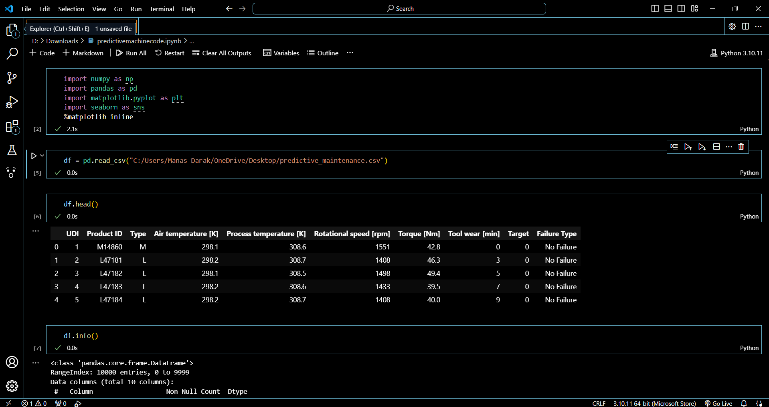

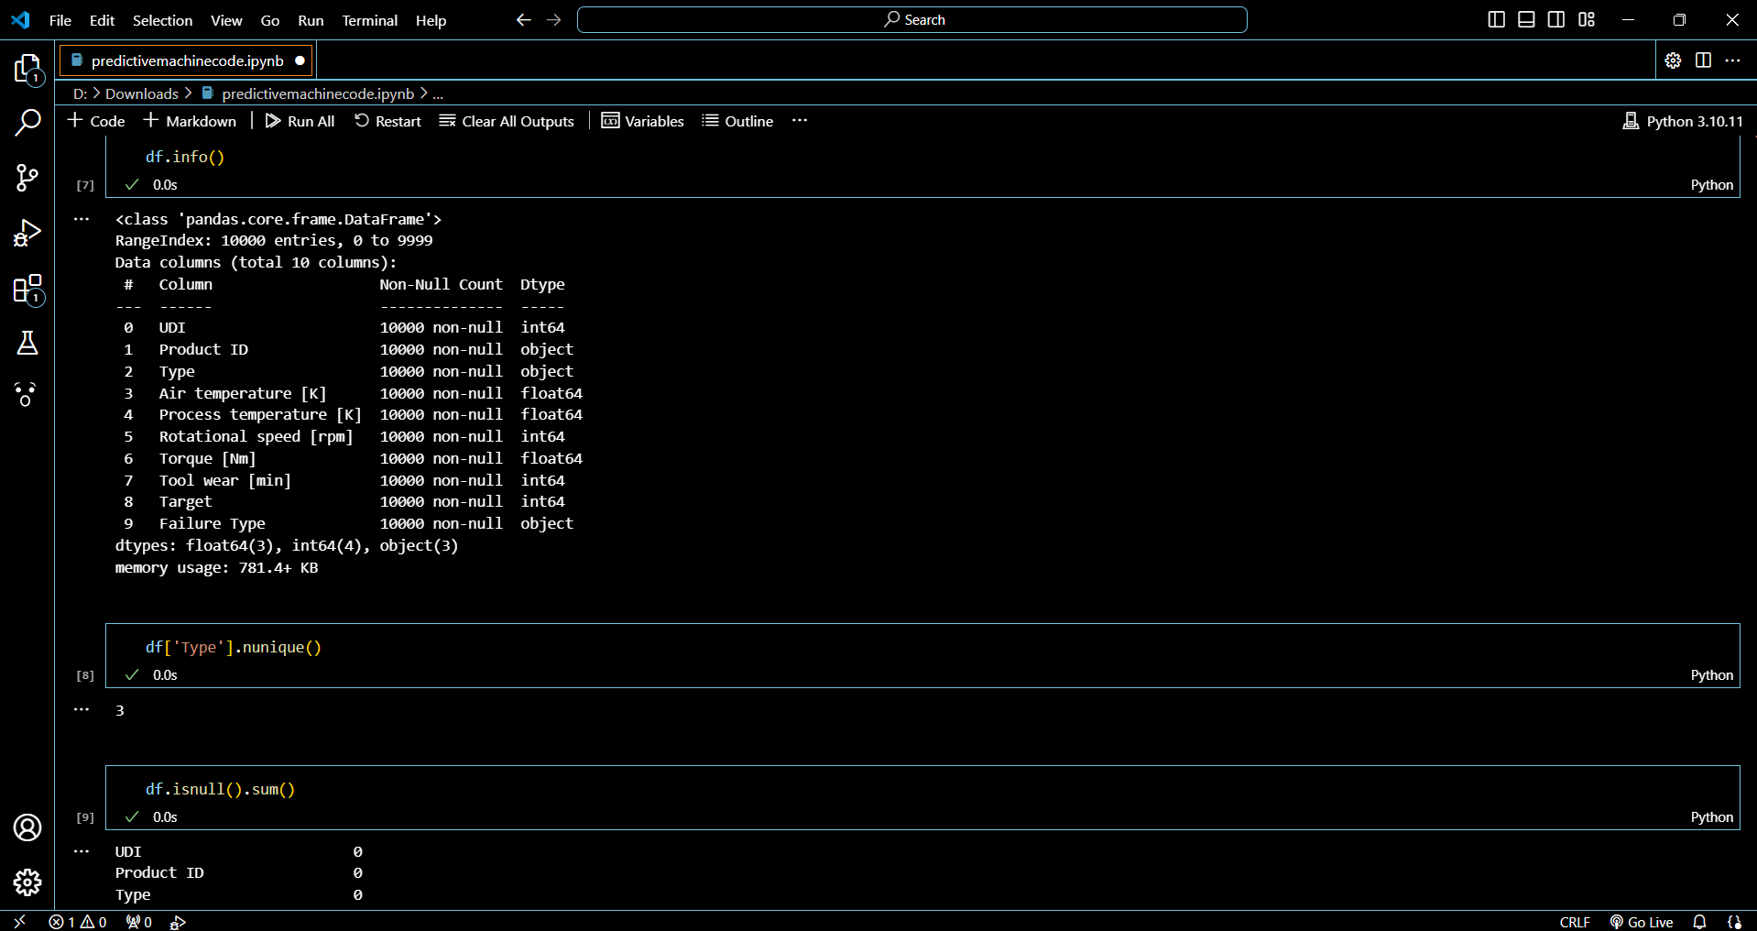
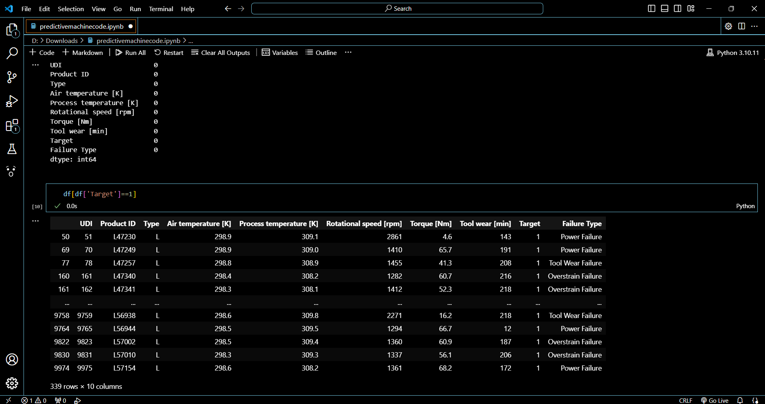
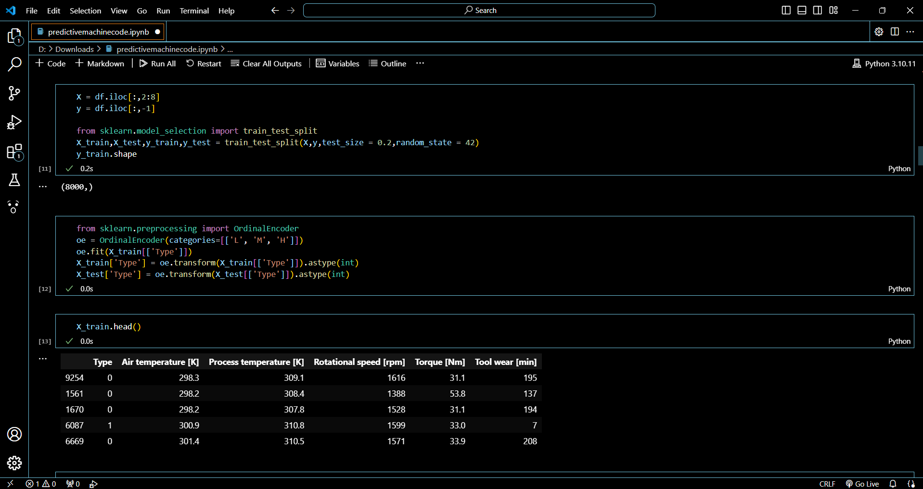

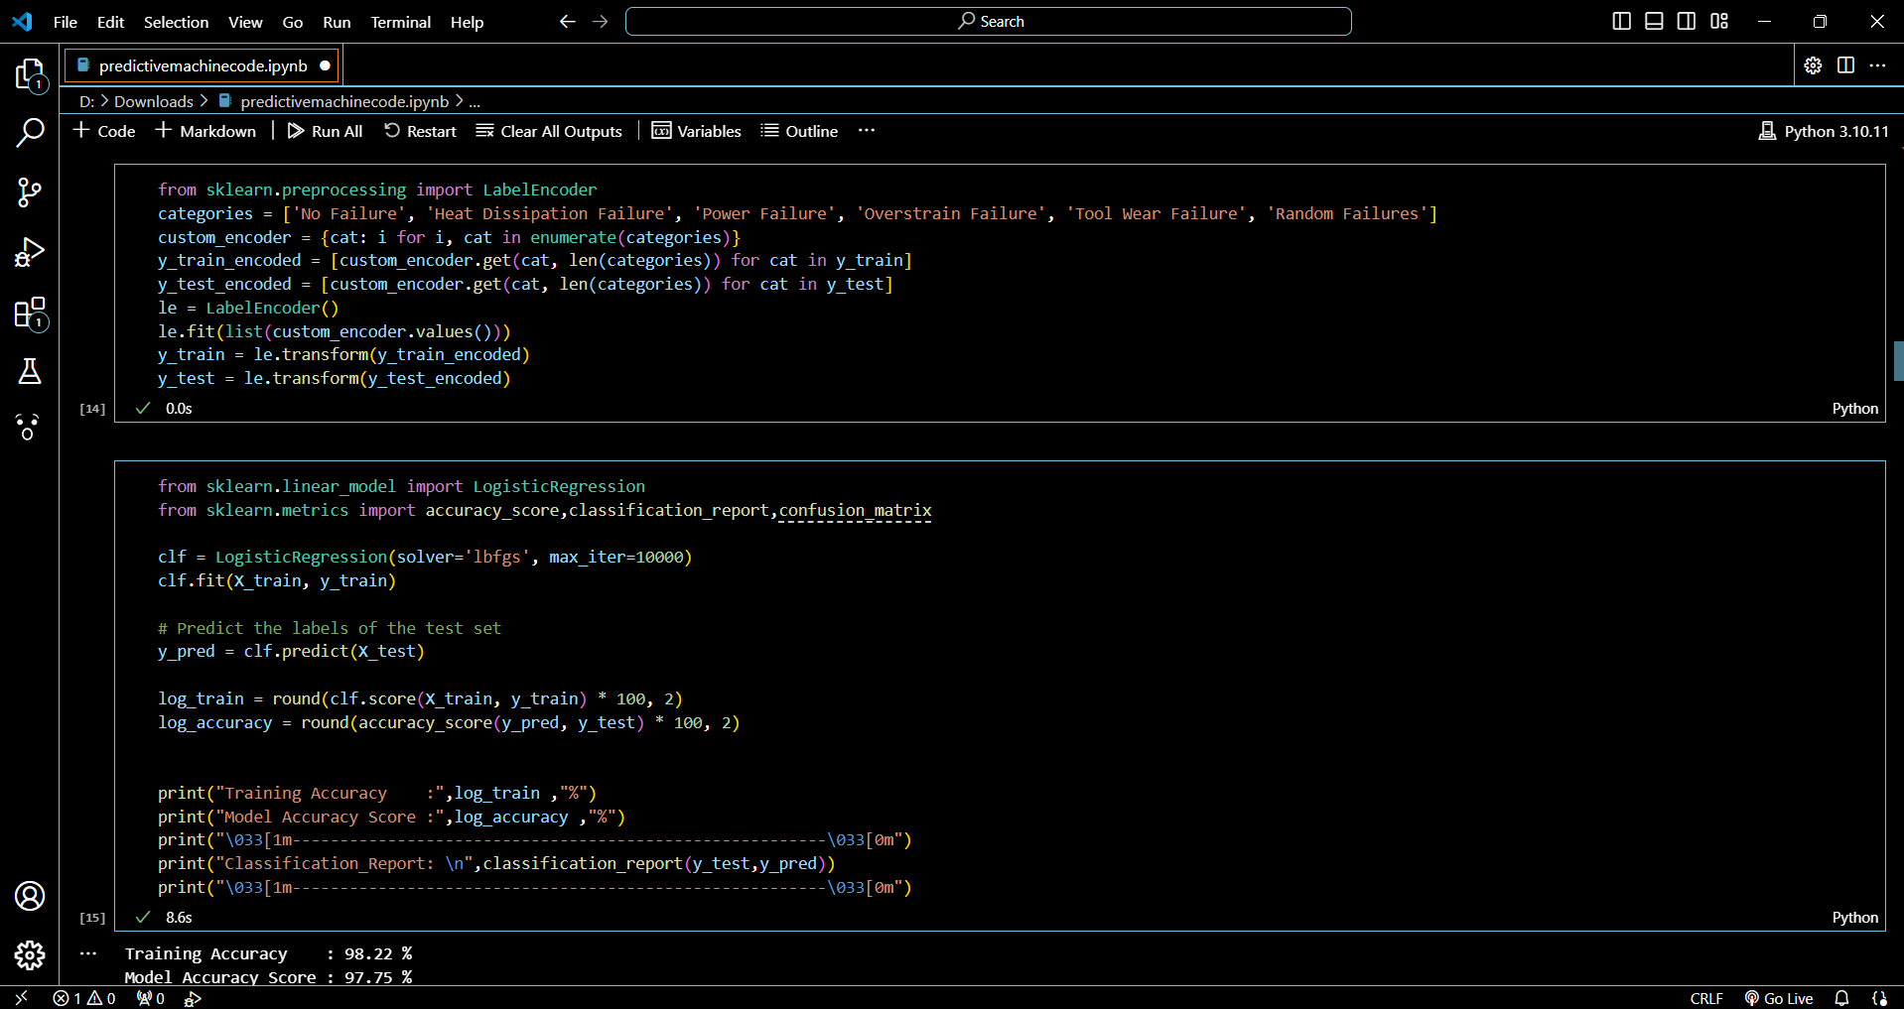

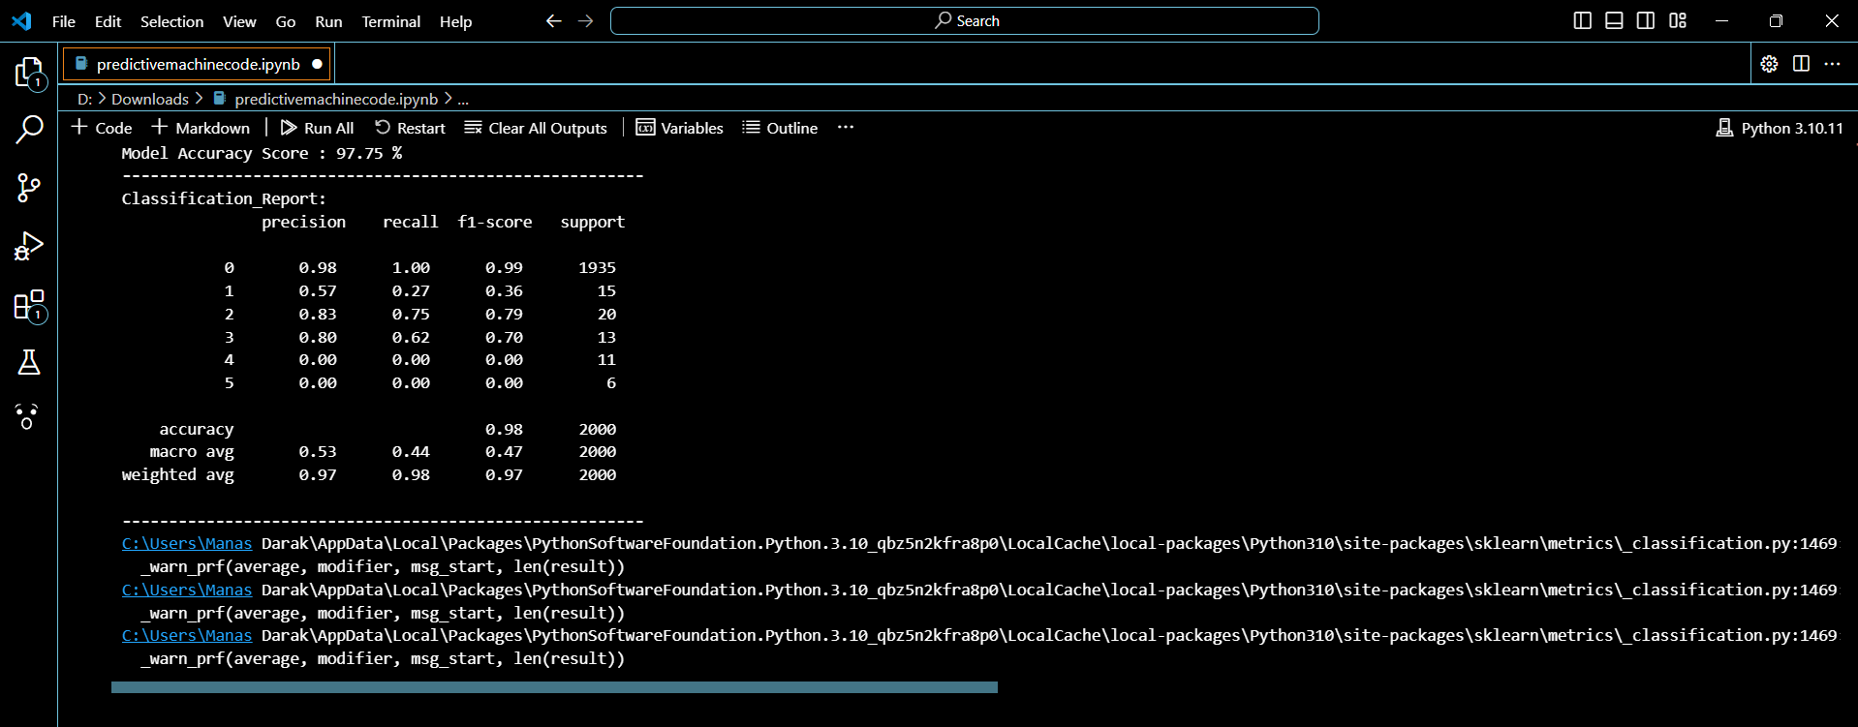

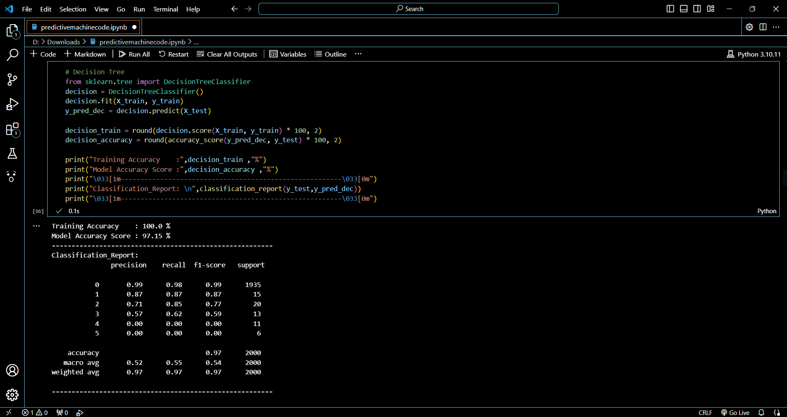

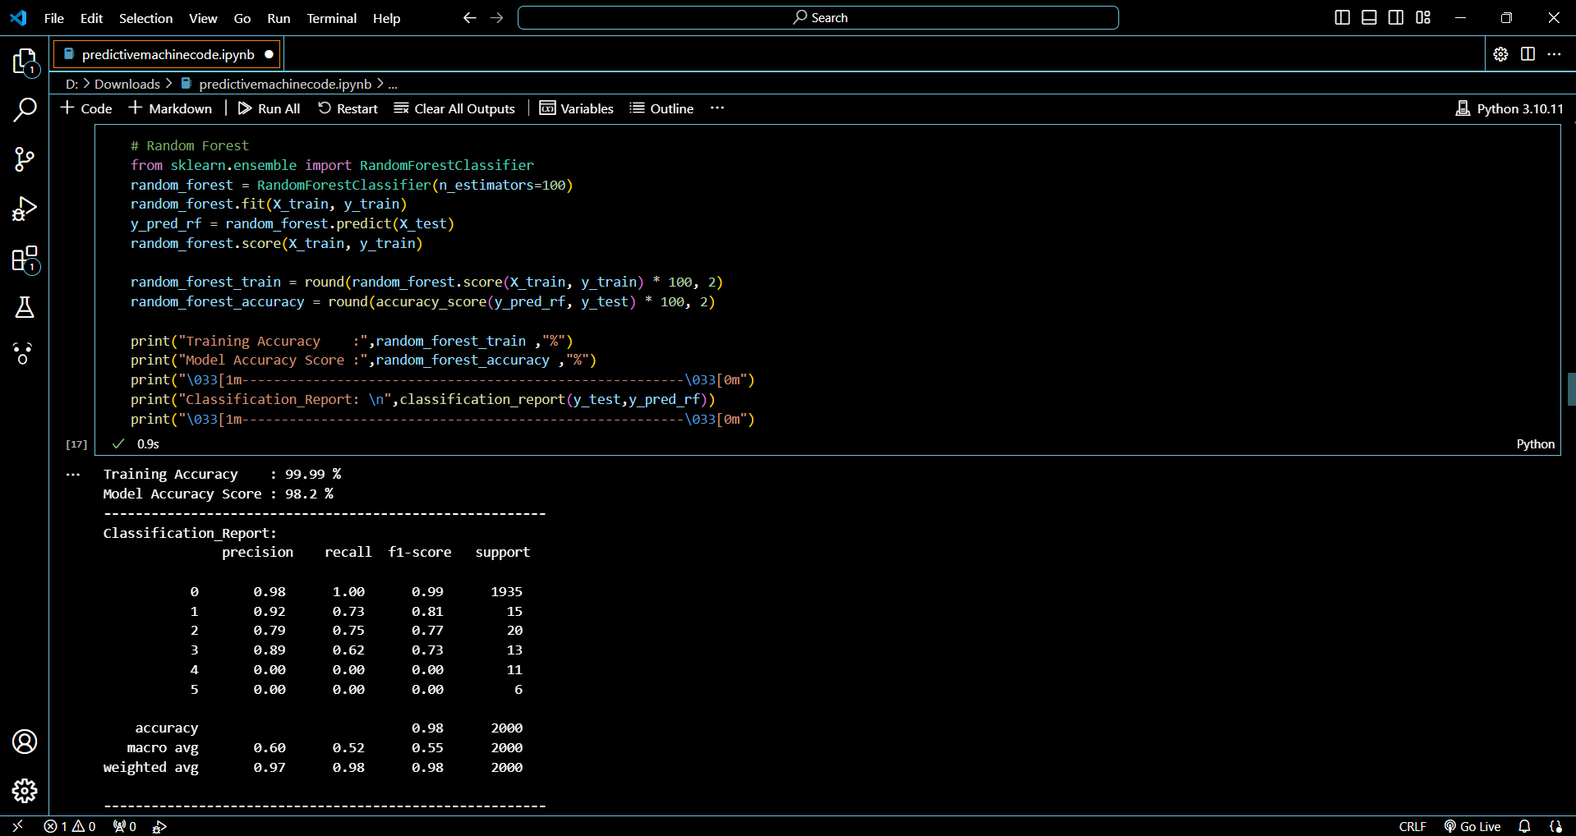
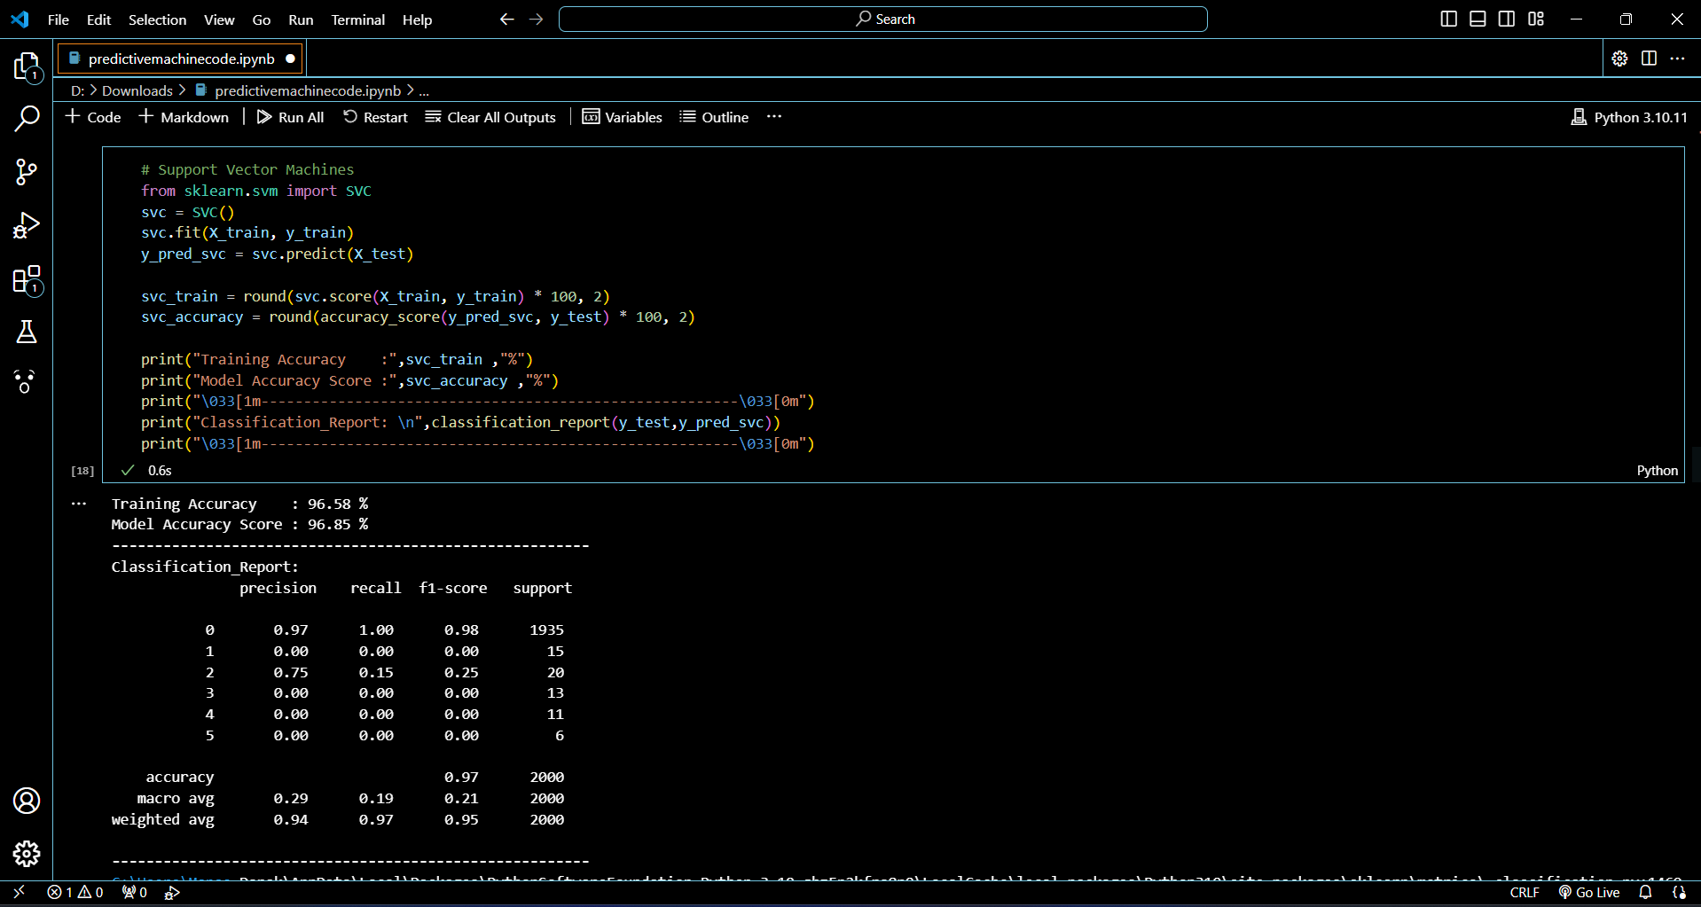

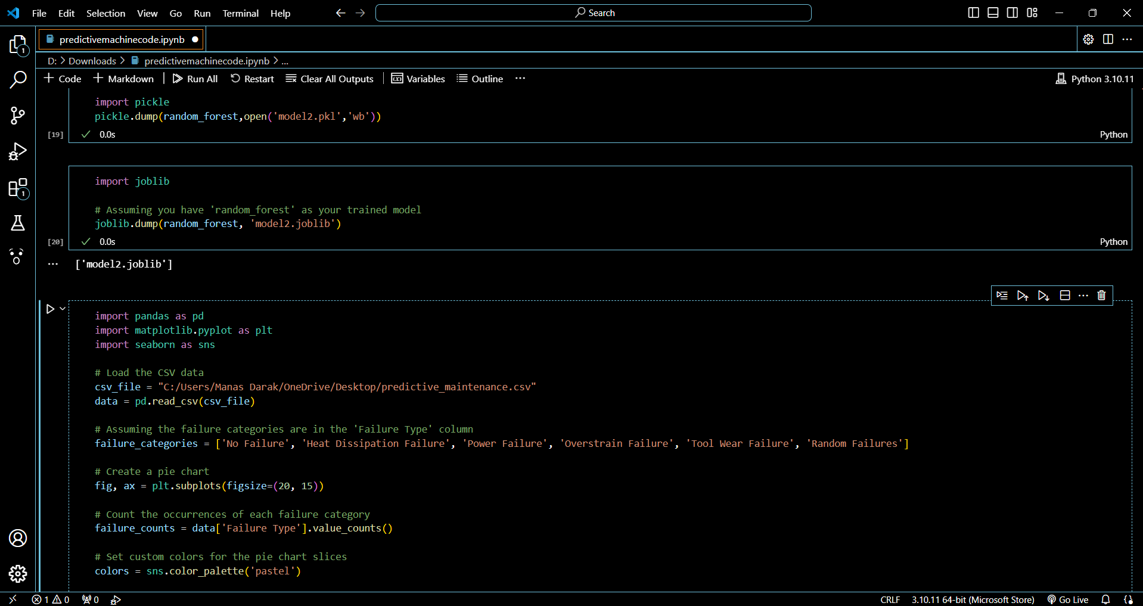
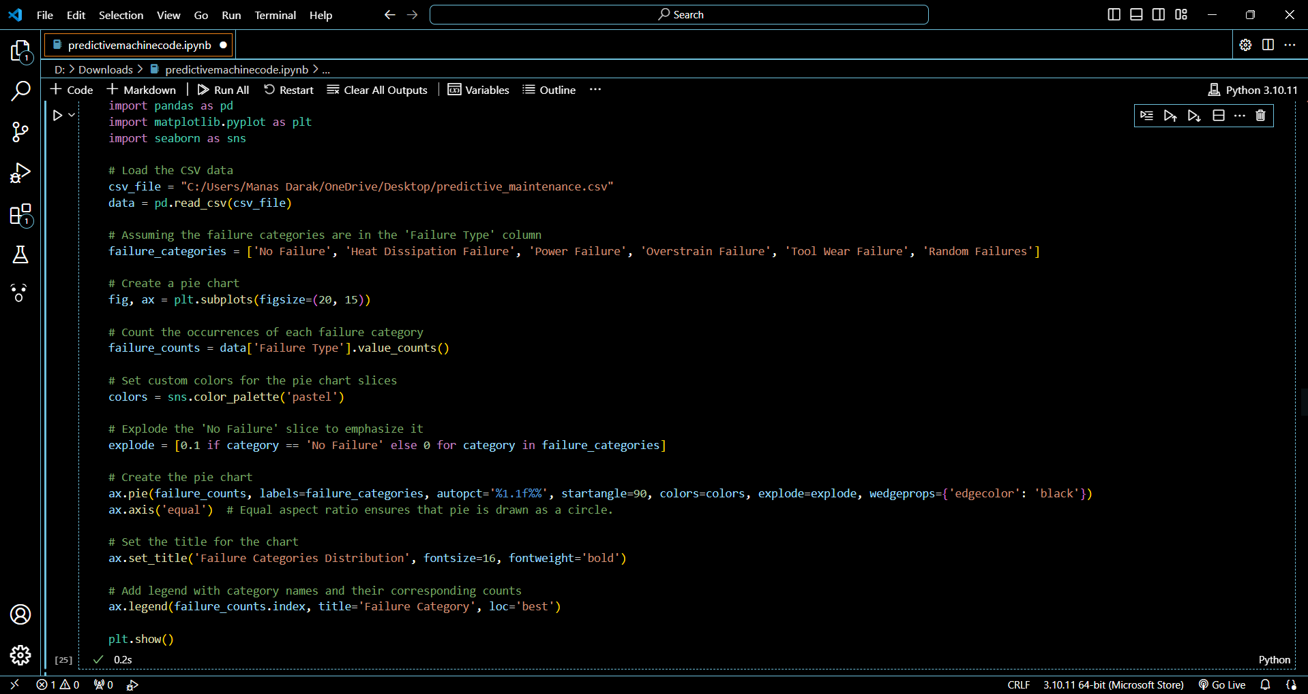
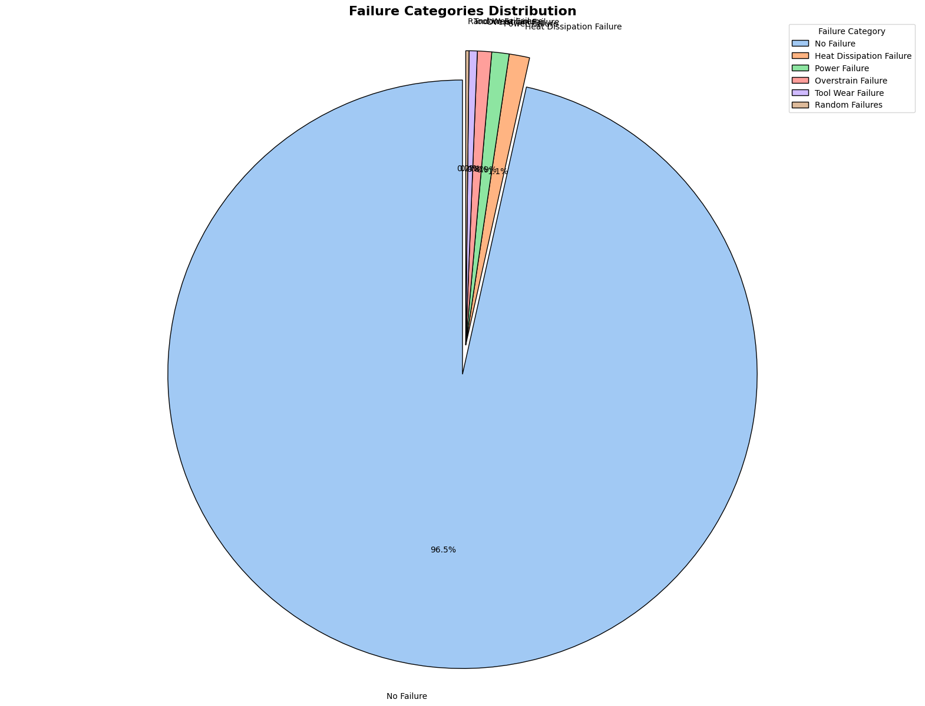

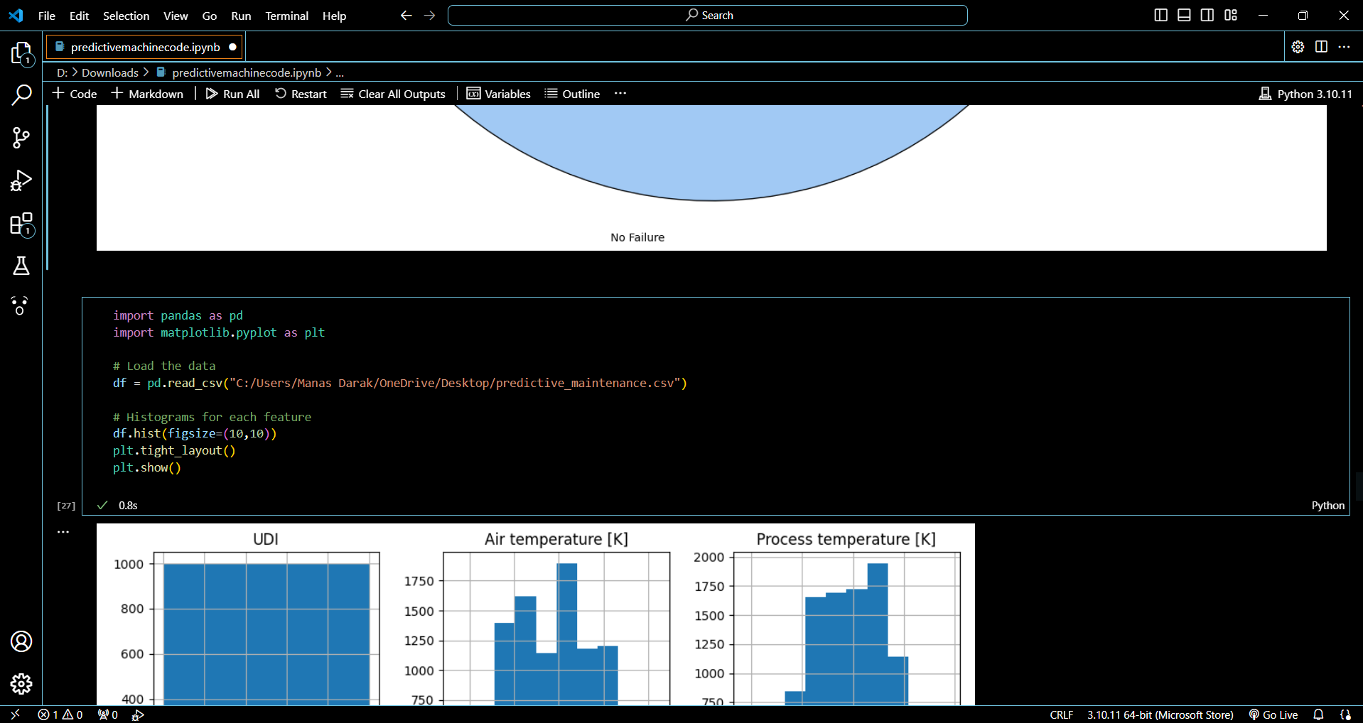

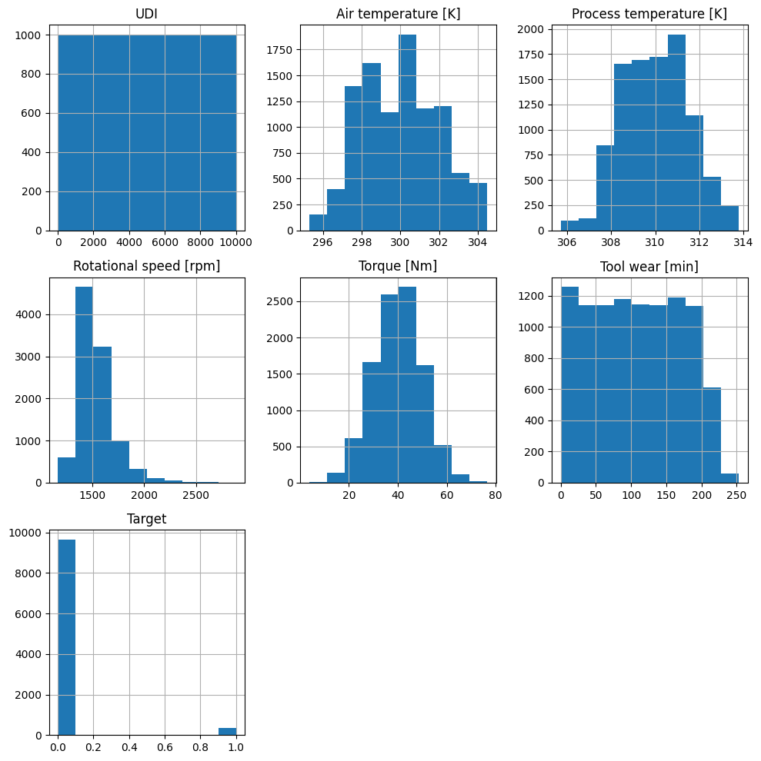
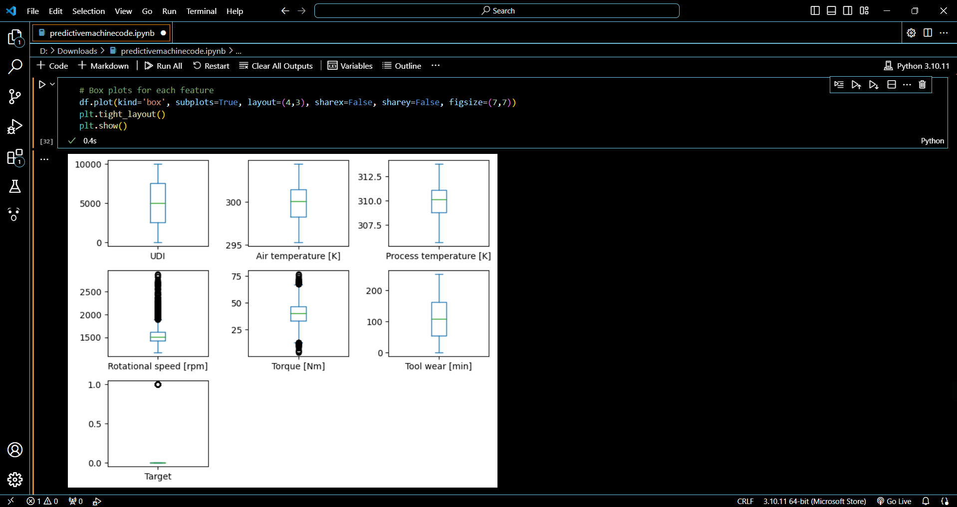

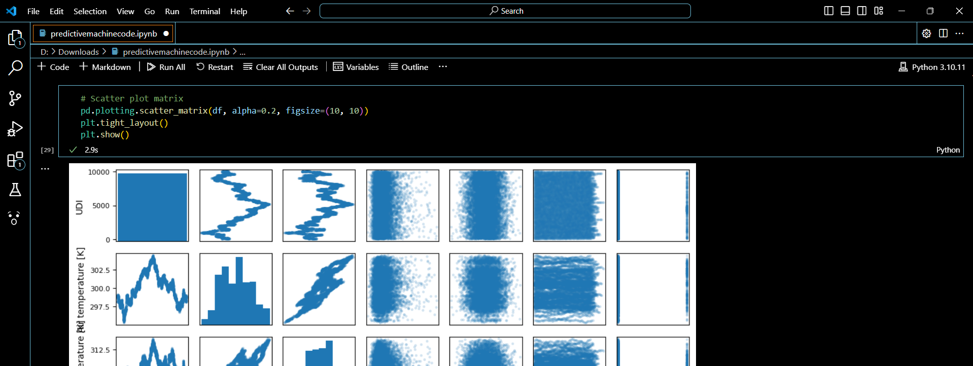

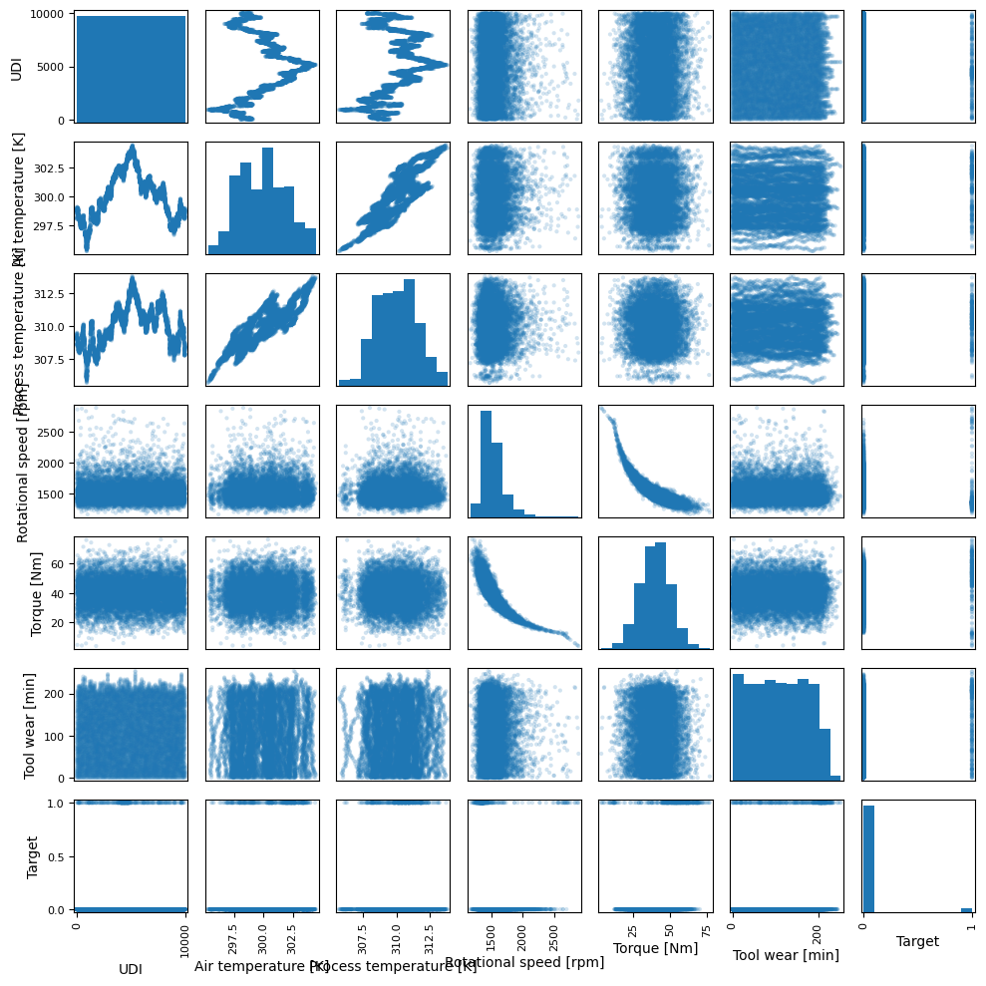

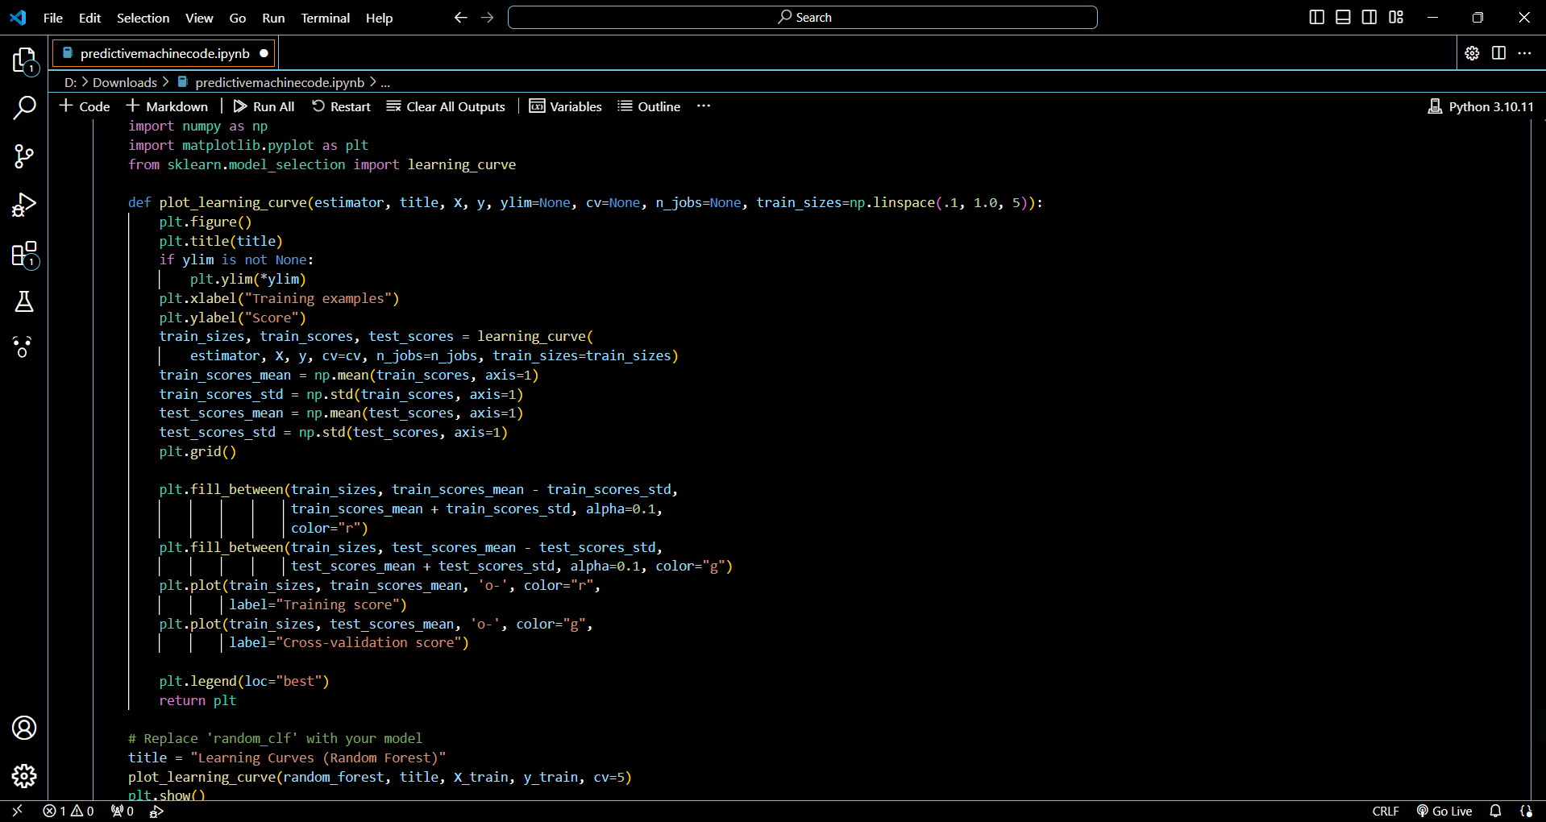

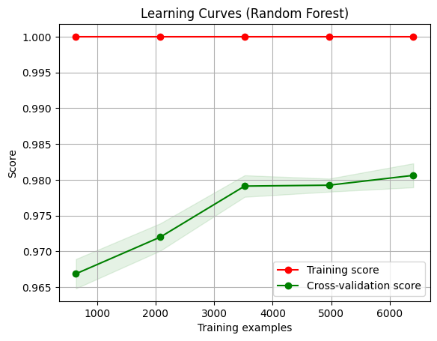

5.3 Confusion Matrix, Precision, Recall, Accuracy, Specificity, Sensitivity All Graph

A detailed confusion matrix was provided to evaluate the true positive and negative rates, as well as false positive and negative rates. Precision, recall, accuracy, specificity, and sensitivity metrics were calculated and represented in graphical forms, including ROC curves and Precision-Recall curves, offering a visual assessment of the model's performance across various thresholds.

6. Conclusions

6.1 Conclusions

The project's findings affirm the efficacy of machine learning in the domain of predictive maintenance. The Random Forest algorithm, in particular, proved effective in discerning patterns indicative of potential equipment failures. It's concluded that the predictive model, with its current level of accuracy and precision, could serve as a reliable tool in an industrial setting to prevent unscheduled downtimes and improve maintenance operations.

6.2 Future Work

Going forward, the model's predictive prowess could be further enhanced by integrating a larger dataset with more diverse variables. Employing deep learning algorithms might offer nuanced insights for complex datasets. Another avenue for improvement is the deployment of the model in a real-time analysis setting, where streaming data can be used for instantaneous predictions.

6.3 Applications

The potential applications of this predictive maintenance model are extensive and varied. Industries with heavy reliance on machinery, such as manufacturing, energy, and transportation, stand to benefit significantly from the insights provided by the model. By adopting this model, these sectors can look forward to not just reduced maintenance costs but also improved operational efficiency and safety standards.

